**CMPE 297 – Special Topics in Software Engineering**

**FALL 2017**



**IOS Application Development**

**Assignment 2 - IOS SQLite Storage Assignment**

**Submitted by- Submitted to-**

Anvit Saxena Prof. Chandrashekhar

SJSU ID: 010953436

1. Created a new project in xcode to develop iOS app using Objective-C as shown below:

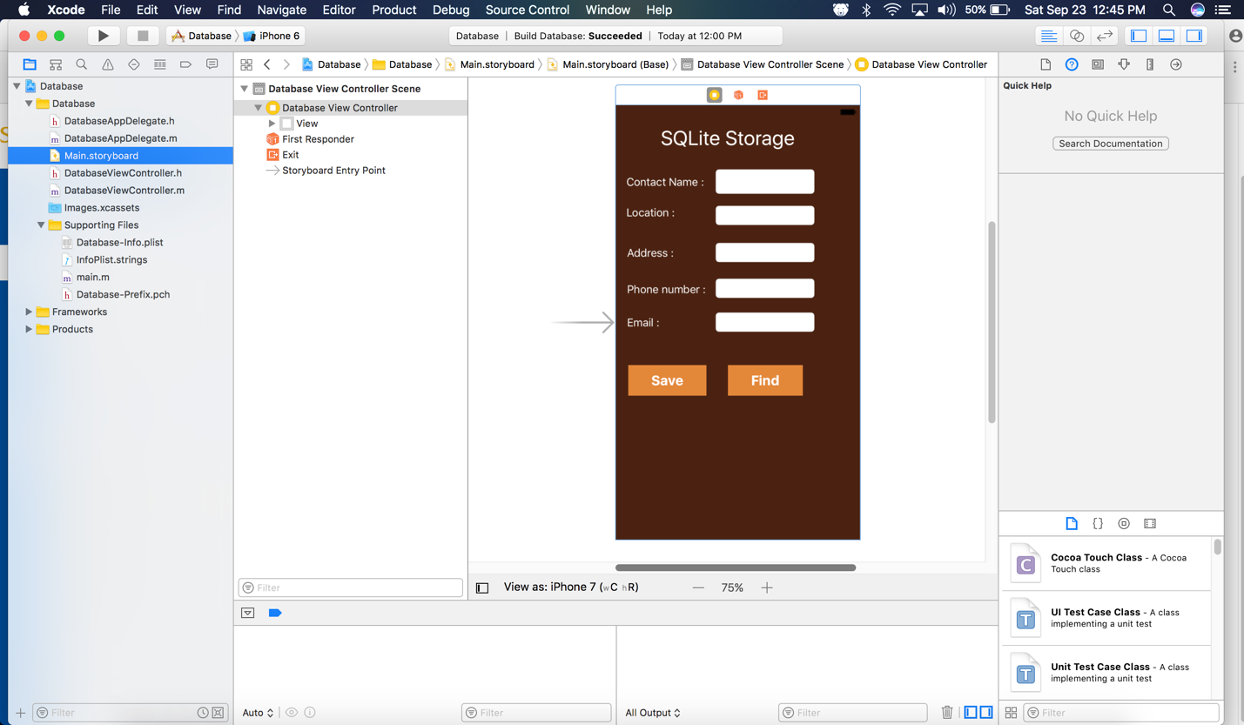

1. This is the DatabaseViewController.m below:

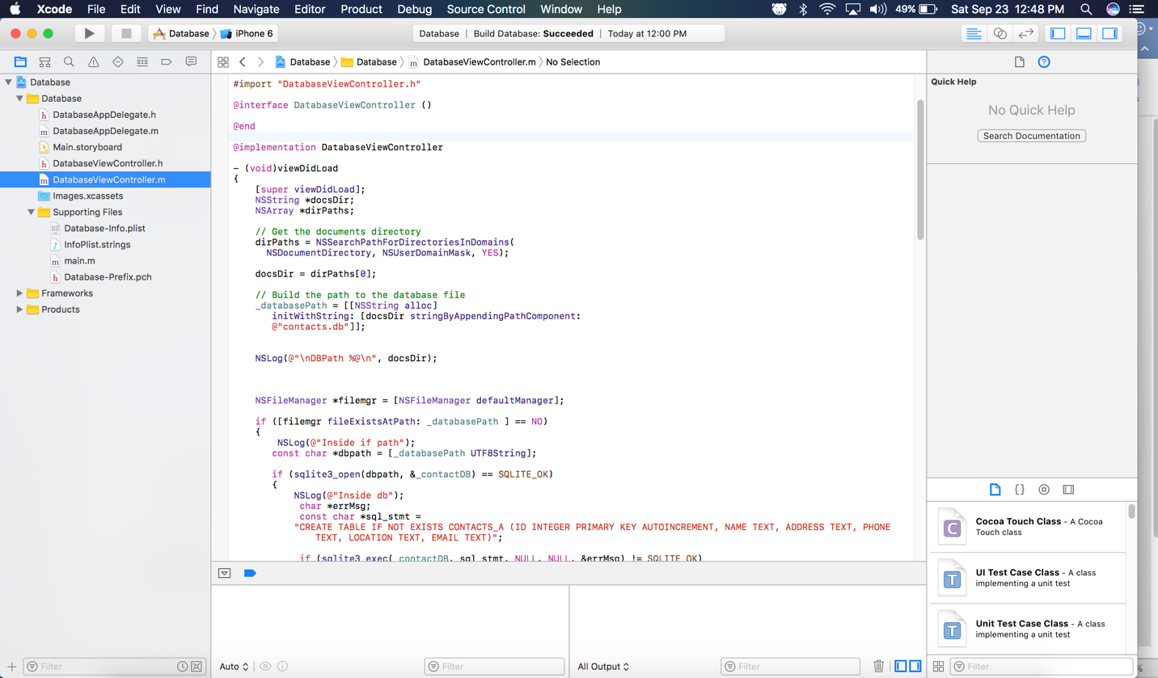

1. This is the DatabaseAppDelegate.m below:

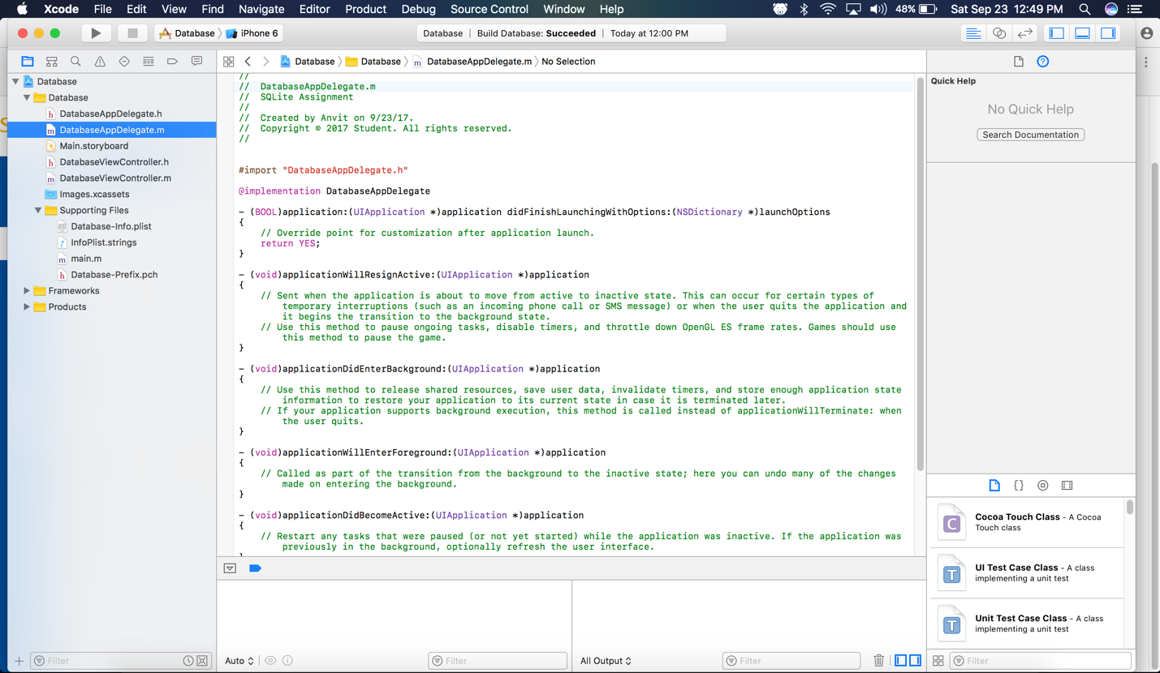

1. The home screen/main storyboard screen capture is as below. This is the main page user receives when the application is opened:

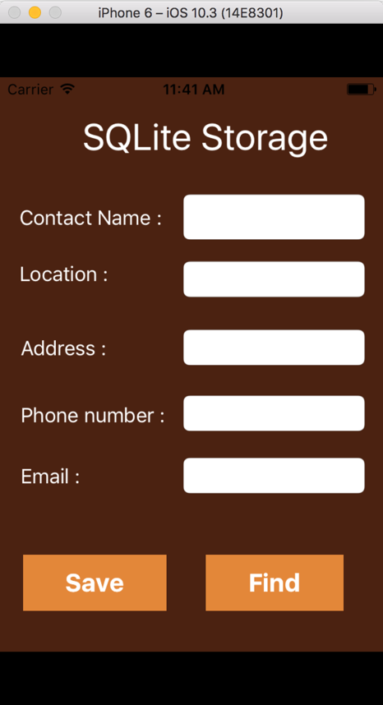

1. When user enters all the details and clicks on Save the record is inserted and a text is displayed saying Contact Added:

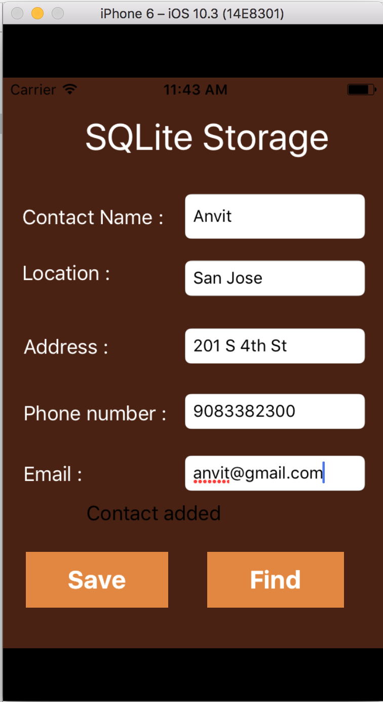

1. User can find the contact by just entering name or any other field and can click the find button. The detail which was saved in Step 5 will be displayed along with the note “Match found” as shown below:

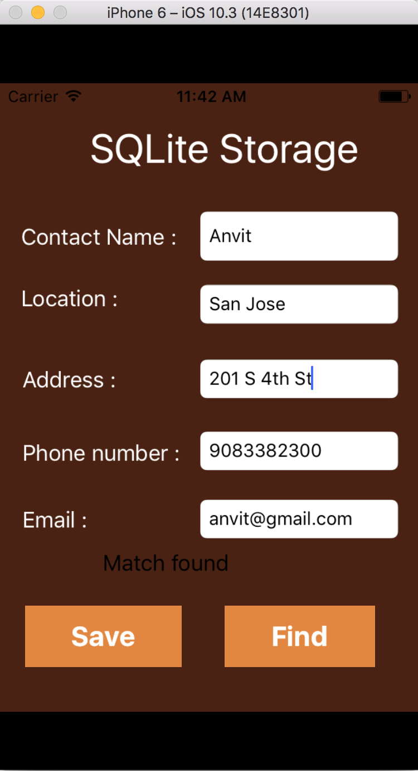

1. Even when the user enters wrong detail while searching it does not find the contact and gives an error saying Match not found as shown below:

